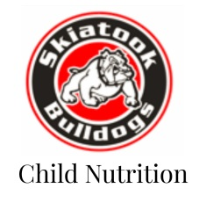
Skiatook Child Nutrition
Dates to Know

September 21, 2023 – Your student’s free or reduced pay status from the 2022-2023 school year will go to full pay if you haven’t turned in a new application for 2023-2024 school year.

Commonly Asked Questions
Q: How will I know if my child was approved for Free or Reduced Lunches?
A: You will receive a letter within 20 days of turning in your application.

Q: How do I turn in my application?
A: You can turn it in 1 of 3 ways
1. Use our new online application at http://www.skiatookschools.org/childnutrition
2. Bring it to 355 S Osage Street Skiatook, OK or your child’s school office
3. Email it to kcarpenter@skiatookschools.org. A fillable PDF of this paper application can be found at http://www.skiatookschools.org/childnutrition

Q: My student never eats at the school. Why should I apply?
A: Well we would love your student to eat with us as we have several yummy options a day but we understand some students like to bring their lunch. However, the district receives funding for every free/reduced student we have. Your application could be helping our school receive funding

Q: Will my application and students pay status be kept confidential?
A: Yes! Extremely confidential! It is a state law that we will not disclose your student’s pay status to anyone, even the student.

Q: I receive food stamps. Do I need to turn in an application?
A: Yes, please turn in an application with your case number or food stamp card number on it.

Q: My child is on Sooner Care. Will they automatically qualify for free lunches?
A: No, unfortunately Sooner Care isn’t a program that automatically qualifies a student. If you are receiving any food benefits (ex. Food Stamps) please write that case number or card number on the application.

Common Application Mistakes
1. Please don’t forget the last 4 of your social security number! Without this we cannot process your application.
2. Please list by name all of the members of your home, even if they are not in school.

